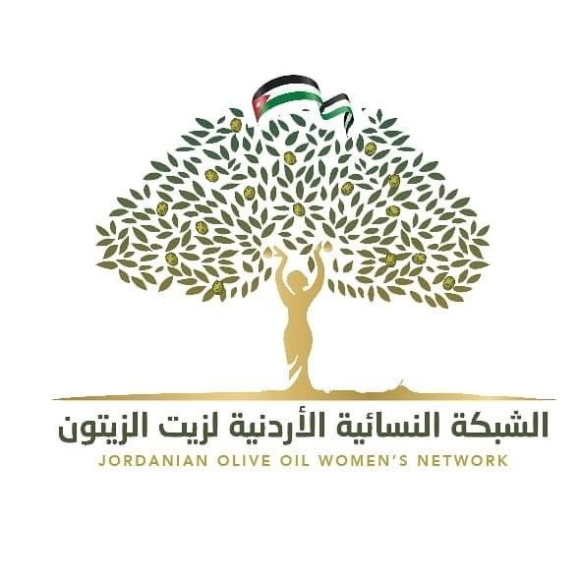

Under the patronage of His Excellency the Executive Director of the International Olive Council, Dr. Abdellatif Ghe dira, and in the presence of the Director of Olives at the Ministry of Agriculture, a representative of the Syndicate of Owners of Press and Jordanian Olive Producers, and experts from the olive sector, Eng. Jamal Al-Batsh, Dr. Murad Al-Maaytah, Eng .Sameer Sulaiman ,members of the network, representatives from the press, audio-visual media and personalities from the local community. The opening of the headquarters of the Jordanian Olive Oil Women’s Network in Al-Jazzazi Company’s mill in the city of Salt, which is considered the oldest mill in Salt, as it was established sixty years ago.
At the outset, Mr. Yousef Al-Jazzazi, owner of the mill and one of the pioneers of the olive sector in Jordan, welcomed the Executive Director of the International Olive Council and thanked him for his visit to Jordan, which coincided with the inclusion of the city of Salt on the World Heritage List. The role of women in developing the olive oil industry and spreading its culture.
The head of the Arab Olive Oil Women's Network ,and the Jordanian Olive Oil Women'sNetwork, Eng. Nehaya Al-Muhaisen, presented an overview of the network as partoftheArab Network, its goals, achievements, future plans and initiatives. She also stressed the importance of choosing its headquarters in the olive mill and integrating women into the olive oil industry and production, which will positively affect quality improvement, marketing development, and an increase in the per capita consumption of olive oil. She appreciated the role of the International Olive Council, its wise management, and its support for establishing these women's olive oil networks in Jordan, Arab and international countries, and supporting their activities and initiatives.
His Excellency the Executive Director expressed his appreciation for providing Al-Jazzazi Mill as a headquarters for the Jordanian Olive Oil Women's Network , and stressed his support for the development of the olive sector and the importance of women's participation in the development of this important sector.
During the celebration, the network members were introduced to their fields of work, achievements and impact on society, then samples of the extra virgin olive oil produced from the Al-Jazzazi mill were tasted by Jordanian experts in sensory evaluation of olive oil and the members of the network.
His Excellency the Executive Director of the International Olive Council was honored by the JOOWN and the owner of the mill.
The Jordanian Olive Oil Women’s Network was established in March 2020 in an initiative that aims to bring together women concerned with olive oil (producers, farmers, nutrition experts, agronomists, tasters, beauticians, industrialists, media professionals, chefs, academics, researchers and many other fields concerned with olive oil).
The main objective of establishing this women’s network was to spread the culture of extra virgin olive oil among the younger generations and all segments of society, to enhance educational activities in schools, universities and associations, and to communicate closely with farms, mills and production companies to learn about the production of extra virgin olive oil and to raise awareness of choosing high olive oil. the 'goodness'.
And in embodiment of these goals to spread awareness and food education in the culture of sensory evaluation of olive oil as a cornerstone of the Mediterranean diet, which has become the focus of the world’s attention to modify the food consumption pattern and the tendency to introduce olive oil into the global diet.
Because of our belief in the great and main role of women in society and the family through caring, educating, educating and nurturing the younger generations and with the passage of time and their tireless work to achieve these awareness-raising goals and nutritional culture with greater efficiency, their ability to develop society, cohesion, teamwork and family stability, the JOOWN has emerged to include in its membership 75 women in many diverse fields concerned with olive oil to provide cultural and professional diversity to set up many activities, events and projects that would improve the methods used in the olive oil production chain and the food culture of the community, which will positively reflect on the community health, economically and socially and work on networking between women to cooperate in achieving maximum desired benefit.
We believe in the importance of producing and consuming high-quality extra virgin olive oil as a cornerstone of the Mediterranean diet, and from here we will proceed seriously with the aim of spreading olive oil culture within a plan of activities and events targeting school and university students and civil society organizations. In parallel, we will work to strengthen the concept of sensory evaluation of olive oil has worked hard to form a trained women’s team and at the hands of international experts in this important field.
In view of the critical importance of integrating academia with industry, we have a future intention to form a team whose mission is to prepare a systematic plan of action to study the educational curricula for school students aimed at raising the awareness of young people about the practical application of scientific information and dedicating the concept of food security, in cooperation with the Ministry of Education..
Currently, the network has completed its institutional steps from the strategic and executive plan by holding specialized courses targeting the axis of women's empowerment and in the presence of international experts specialized in extra virgin olive oil. These principles include sensory evaluation of olive oil, marketing, packaging, e-marketing, project management, entrepreneurship and various topics in human development.
The network also implemented the initiatives of the grandparents’ treasure as a treasure for the grandchildren, and the initiative of a cup of oil for every home, and check your oil before it enters your home. And sensory evaluation for children...
The network seeks to establish partnerships with the public and private sectors to ensure the achievement of its goals and to allow women to professionalize the production, dissemination, education and teaching practices related to extra virgin olive oil.

